A Better Florist - When Luxury Meets Flowers

Every one of us has special people in our lives, and there’s no month that passes by without having to treat someone with a gift for a birthday, flowers for graduation or anniversary bouquet. It’s just the way it works. But, there’s a florist in Singapore that makes all the shopping for us effortless, and that’s the best florist in Singapore - A Better Florist.

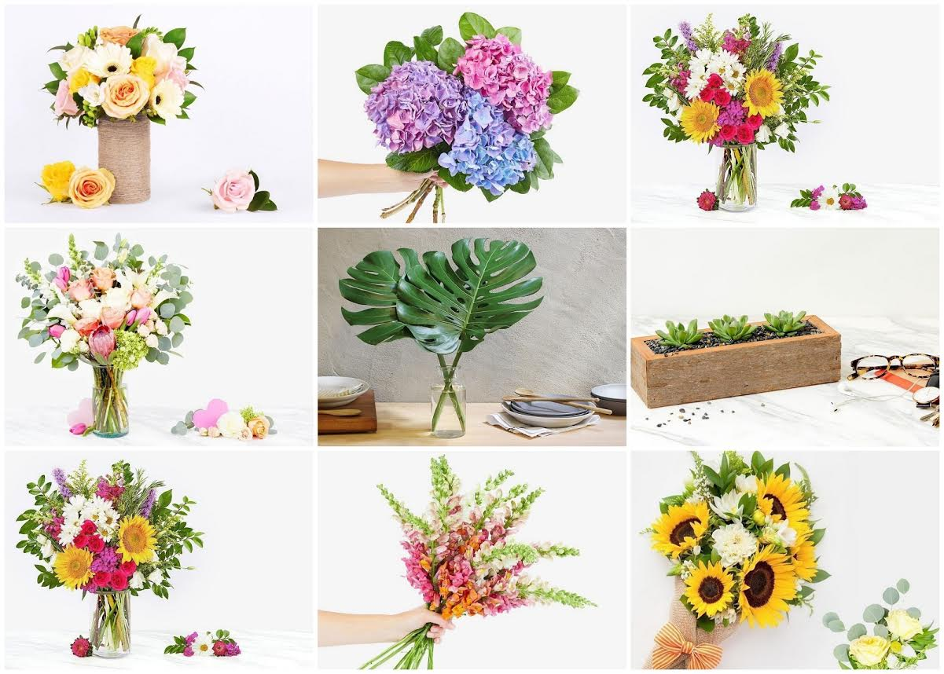

As an innovation in the floristry industry of Singapore, ABF offers significantly more luxurious and inventive designs of bouquets and floral arrangements than all others in Singapore. From funeral flowers to wedding flowers there’s nothing they can’t craft. They create rich and stunning grand opening flowers, such as a grand opening flower stand, bu they are also great at listening to what you need and creating a bouquet that’s going to thrill your fiance, or a bouquet for Mother’s Day that’s going to touch your Mother's heart. These florists have a way of telling your story, so it’s safe to call them bloom whisperers.
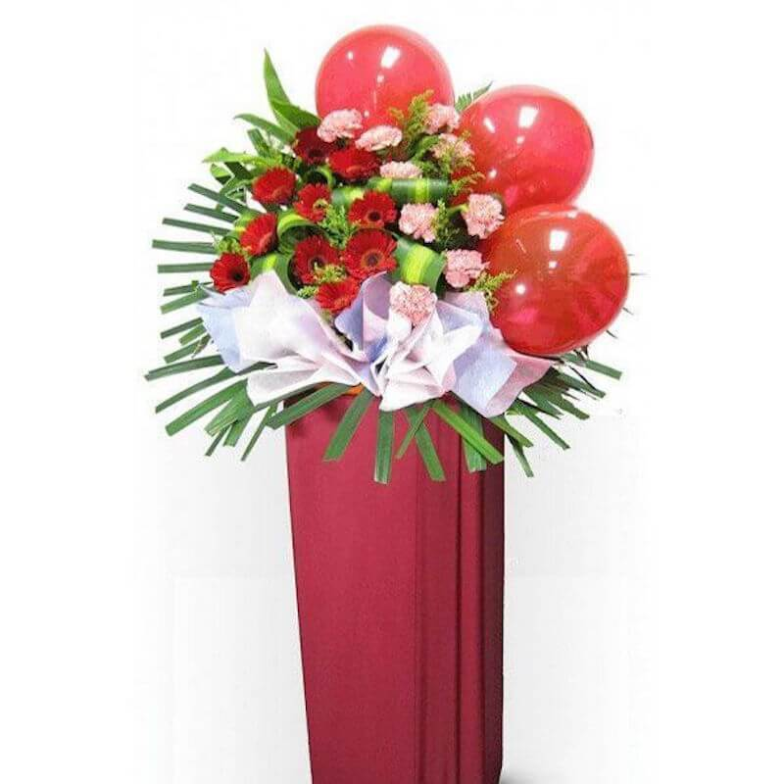

All the busy types, which seems to be everyone these days, are going to appreciate their flower, hamper and fruit basket delivery. That’s right, this is both a gift and a flower shop, offering customisable hampers and fruit baskets for a wide range of occasions. Their fruit basket is appealing to even those who aren’t into the healthy lifestyle. There’s just something they get right when it comes to design, you can’t help but feel it’s the right gift to buy. These alluring designs can instantly be ordered, and shopping is so easy and simple. Jump online and pick one of the bouquet from their collections, whichever suits your taste. Afterwards, all you have to do is press the order button.
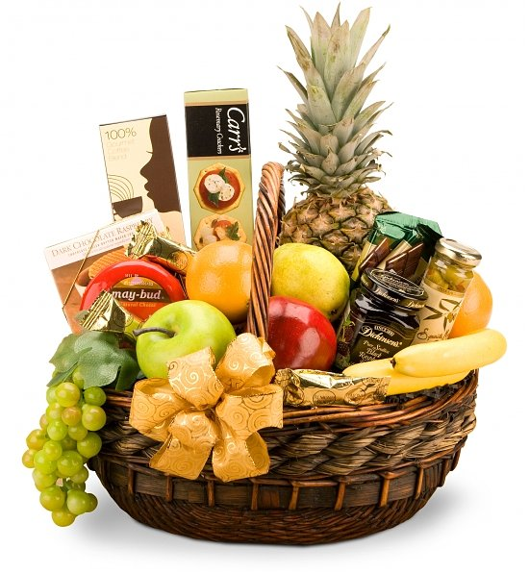

Want to get same day flowers? Fortunately, with these guys your dreams do come true. You’ll get your flowers on the same day, every single time, and what’s even better, it doesn’t cost anything extra. There’s no other online florist in Singapore who can do that, which is why it has already received so many positive reviews as the best flower delivery in Singapore. Plus, they have an express flower delivery option, which arrives to any place in Singapore within just 90 minutes, and it doesn’t break your bank.

They’re also quite affordable, whether we’re talking about their Dubai flower delivery or their KL flower delivery or their exquisite Hong Kong flower delivery. Their selection always has a variety of bouquets with different prices so that everyone can afford their beautiful creations. It’s all about sharing the love, not being able to afford it, which is why they are known as the best florist in Dubai and the best florist in Hong Kong as well.

If you’re not convinced that A Better Florist is your dream florist, you’ll love to hear that this business has expanded to Kuala Lumpur, where they already regard it as the best florist in Kuala Lumpur. It’s also the best florist in Hong Kong where as the best flower delivery in Hong Kong, takes the number one spot in the floristry industry. And finally, they are a flower delivery Dubai and Singapore love because they really do care, and it shows through what they create. You’re getting a taste of luxury, but it doesn’t hurt your pockets either.

When in Singapore, do as Singaporeans do and indulge yourself in some flower shopping at A Better Florist’s world of flowers.

